Advanced JUnit Testing Exercises

Exercise 1: Parameterized Tests

Scenario:

You want to test a method that checks if a number is even. Instead of writing multiple test cases, you will use parameterized tests to run the same test with different inputs.

Steps:

1. Create a new Java class `EvenChecker` with a method `isEven(int number)`.
2. Write a parameterized test class `EvenCheckerTest` that tests the `isEven` method with different inputs.

Use JUnit's `@ParameterizedTest` and `@ValueSource` annotations.

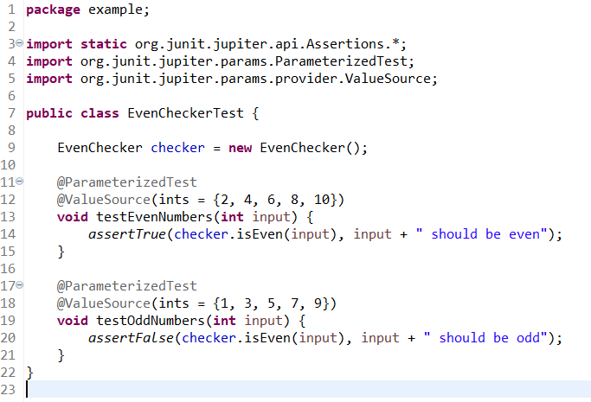

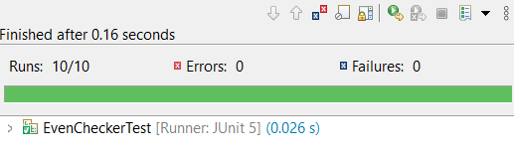

Exercise 2: Test Suites and Categories

Scenario:

You want to group related tests into a test suite and categorize them.

Steps:

1. Create a new test suite class `AllTests`.
2. Add multiple test classes to the suite.

Use JUnit's `@Suite` and `@SelectClasses` annotations.

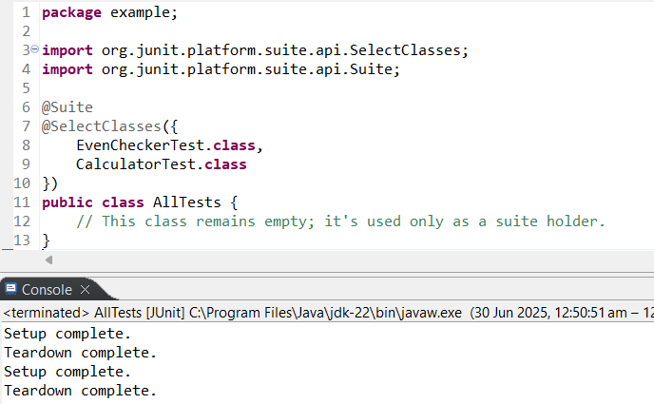\

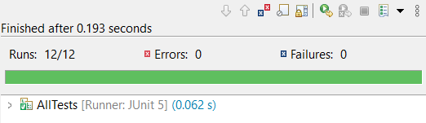

Exercise 3: Test Execution Order

Scenario:

You want to control the order in which tests are executed.

Steps:

1. Create a test class `OrderedTests`.
2. Use JUnit's `@TestMethodOrder` and `@Order` annotations.

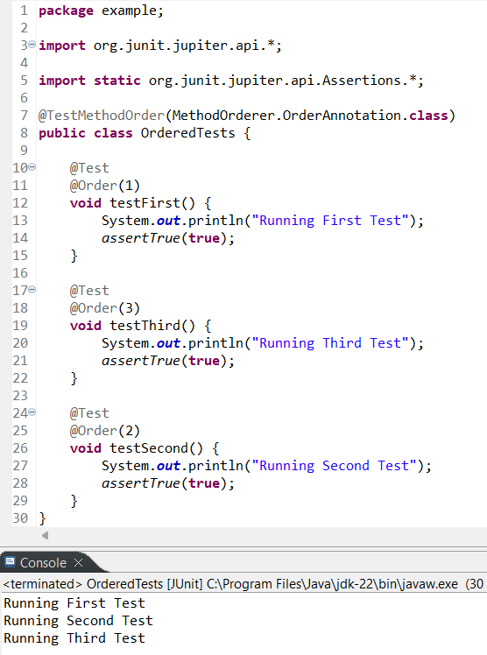

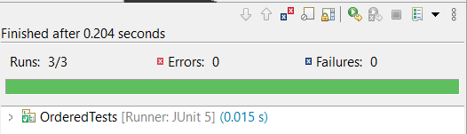

Exercise 4: Exception Testing

Scenario:

You want to test that a method throws the expected exception.

Steps:

1. Create a class `ExceptionThrower` with a method `throwException`.

Write a test class `ExceptionThrowerTest` that tests the method for the expected exception.

**ExceptionThrower.java:**

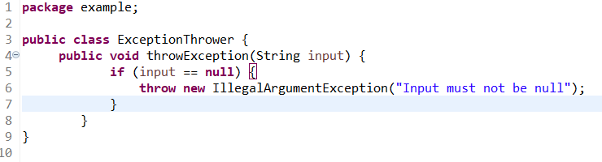

**ExceptionThrowerTest.java:**

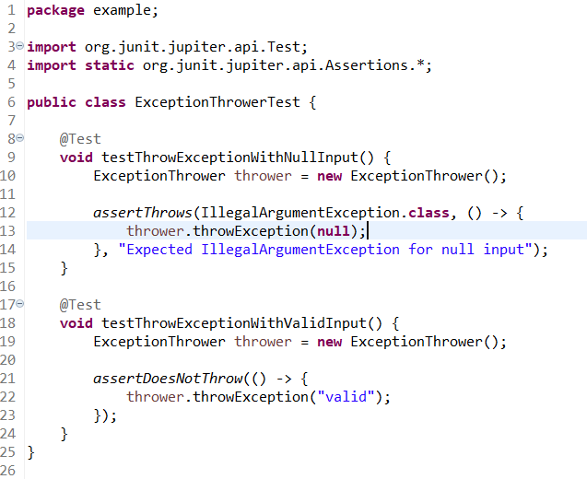

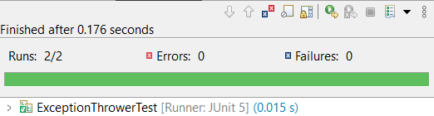

Exercise 5: Timeout and Performance Testing

Scenario:

You want to ensure that a method completes within a specified time limit.

Steps:

1. Create a class `PerformanceTester` with a method `performTask`.

Write a test class `PerformanceTesterTest` that tests the method for timeout.

**PerformanceTester.java:**

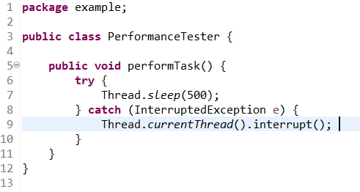

**PerformanceTesterTest.java:**

